**Assembler Project**

Project in CAO1, 3rd Semester. Counter project is made for counting, detecting movement of people passing through certain way. Project is made using Adeept Mega 2560 Arduino microcontroller.

**Problem statement**

What can be done to detect movement of people passing through certain way?

* LightOn - state where LED is on.
* LightOff - state where LED is off.

**Design**

The purpose of this project is to detect movement of people passing through certain way.

When there is movement in front of PIR Movement sensor program goes to LightOn state, after 3 seconds it goes back to LightOff state.

**Testing**

PIR Movement sensor test and LED:

Purpose for the test is to test PIR Movement sensor and LED.

**Excepted result:**

When there is movement in front of PIR Movement sensor the LED lights up.

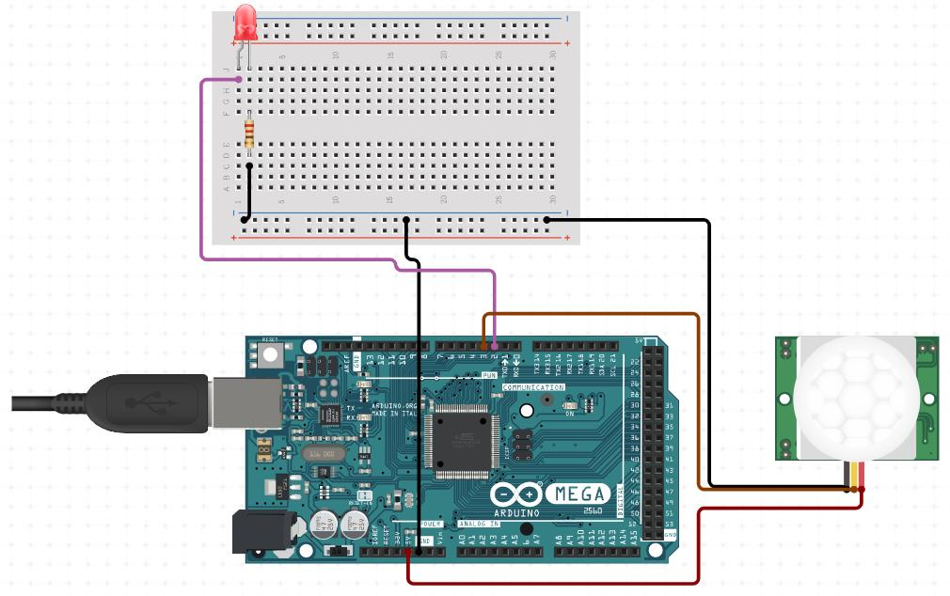

**Code:**

LDI R21, (1 << PE4);set the register

OUT DDRE,R21 ;set port E to output

//LDI R22,0xFF

//OUT DDRB,R22 ;set portB to output

hel:

IN R20,PINE;set the register

ANDI R20, (1 << PE5);do and

CPI R20,0 ;compare R20 and 0

BRNE on ;if not,go to on

LDI R17,0

OUT PORTE,R17

JMP hel

on:

LDI R17, (1 << PE4);set the register

OUT PORTE,R17

JMP hel

Result:

Result as expected. When there is movement LED light up.

**Project diagram**

Things used:

1. 6 Wires
2. 1 PIR Movement sensor
3. 1 Adeept mega 2560 microcontroller board
4. 1 Breadboard
5. 1 LEDs
6. 1 220Ω resistors

PIR Movement sensor is connected to 3 wires, one is connected to ground to microcontroller, one is connected to 5V power to microcontroller and the other wire is connected to pin 3. Pin 2 from microcontroller is connected to breadboard where is connection to the LEDs. The resistor is connected to negative leg of LEDs.

